Week14

**Q1)**Youaretransportingsomeboxesthroughatunnel,whereeachboxisaparallelepiped,andis characterized by its length, width and height.

The height of the tunnel ***41*** feet and the width can be assumed to be infinite.A box can be carried throughthetunnelonlyifitsheightisstrictlylessthanthetunnel'sheight.Findthevolumeofeach box that can be successfully transported to the other end of the tunnel. Note: Boxes cannot be ro- tated.

# InputFormat

Thefirstlinecontainsasingleinteger***n***,denotingthenumberofboxes.

***n***linesfollowwiththreeintegersoneachseparatedbysingle spaces

-***lengthi***,***widthi***and***heighti***whicharelength,widthandheightinfeetofthe***i***-thbox.

# Constraints

***1≤n≤100***

***1≤lengthi,widthi,heighti≤100***

# Output Format

Foreveryboxfromtheinputwhichhasaheightlesserthan ***41***feet,printitsvolumeinaseparate line.

# SampleInput0

4

555

1240

10541

7242

# SampleOutput0

125

80

# Explanation0

Thefirstboxisreallylow,only***5***feettall,soitcanpassthroughthetunnelanditsvolumeis ***5x5x 5 = 125***.

Thesecondboxissufficientlylow,itsvolumeis***1x2x4==80***.

Thethirdboxisexactly***41***feettall,soitcannotpass.Thesamecanbesaidaboutthefourthbox.

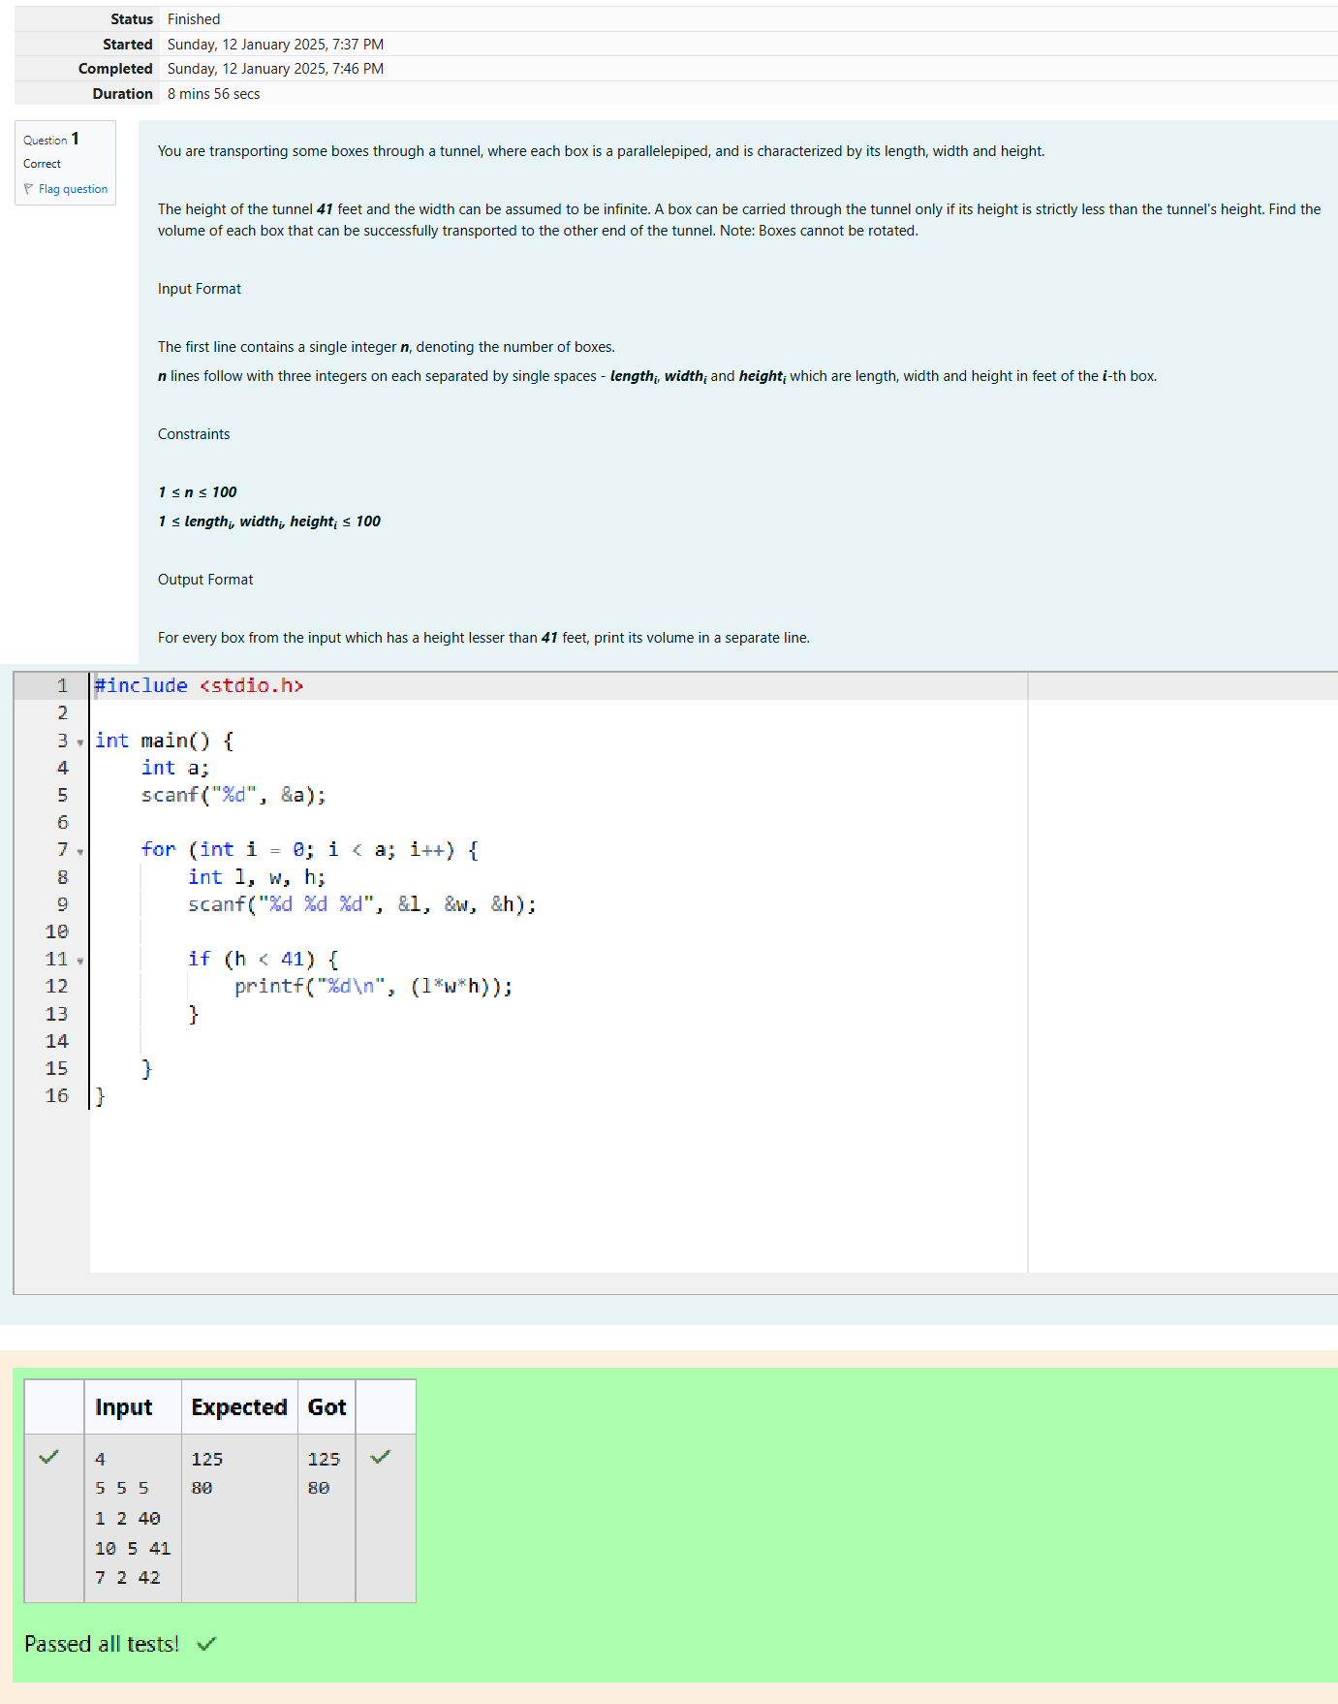

**Q2)** You are given ***n*** triangles, specifically, their sides ***ai***, ***bi*** and ***ci***. Print them in the same style but sortedbytheirareasfromthesmallestonetothelargestone.Itisguaranteedthatalltheareasare different.

Thebestwaytocalculateavolumeofthetrianglewithsides***a***,***b***and***c***isHeron'sformula:

***S =Öp*(p–a)* (p -b)*(p–c)***where***p= (a+b +c) /2***.

# InputFormat

Firstlineofeachtestfilecontainsasingleinteger ***n***.***n*** linesfollowwith***ai***,***bi*** and***ci*** oneachsepa- rated by single spaces.

# Constraints

***1≤n≤100***

***1 ≤ai, bi,ci≤70***

***ai+ bi> ci,ai+ci>biandbi+ ci>ai***

# Output Format

Printexactly***n***lines.Oneachlineprint ***3***integersseparatedbysinglespaces,which are ***ai***, ***bi*** and ***ci*** of the corresponding triangle.

# SampleInput0

3

7 24 25

5 12 13

345

# SampleOutput0

345

5 12 13

7 24 25

# Explanation0

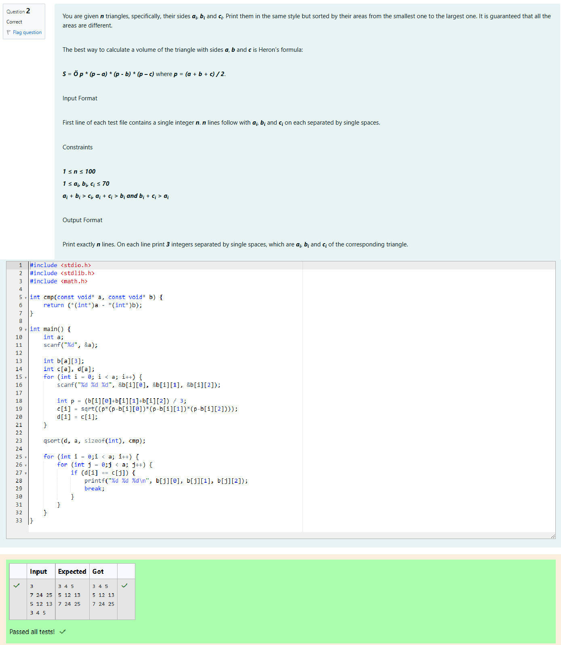Thesquareofthefirsttriangleis ***84***.Thesquareofthesecondtriangleis***30***.Thesquareofthethird triangle is ***6***. So the sorted order is the reverse one.